LOCATION PLAN

The factory guidance-how to reach from Branch Office to Company Name

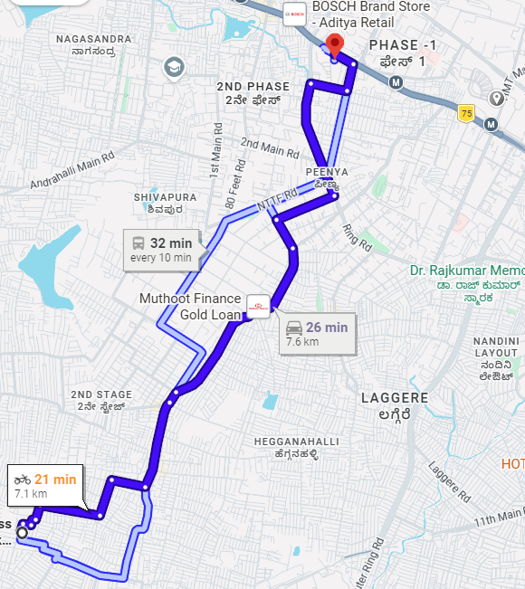

- It will take approx. 30 Min.

For Company Name
Name:
Designation:
Date:
Signature and stamp

